BUILD AND CONFIGURE A SAMLL OFFICE NETWORK DELIVERABLE
- Assign static IP addresses to five devices (laptops or desktops) on your home or lab network, ensuring each is in the same subnet, and verify connectivity between them using the ping command.
Answer
Static IP Setup for 5 Devices
Use the same subnet, for example 192.168.10.0/24.
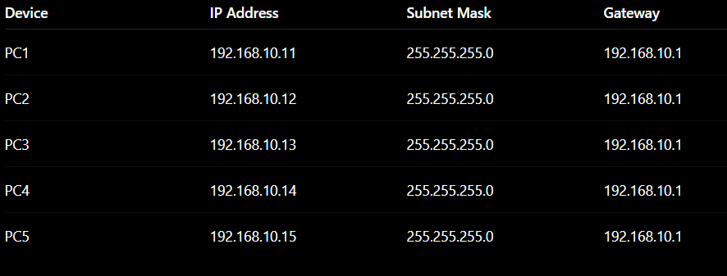
Verify Connectivity
On each PC, open Command Prompt and run:
ping 192.168.10.12
Test other devices similarly:
ping 192.168.10.13
ping 192.168.10.14
ping 192.168.10.15
Expected result:
Reply from 192.168.10.12: bytes=32 time<1ms TTL=128
- Set up a DHCP server (using your router or software like Packet Tracer/GNS3/VirtualBox) to automatically assign IP addresses to at least three devices, and confirm that each device receives a unique IP from the correct range.
Answer

Step 1: Build the Topology
- Place the following devices on the Packet Tracer workspace:
  - 1 Router (e.g., 2911) or 1 Generic Server (acting as DHCP_Server)
  - 1 Switch (e.g., 2960)
  - 3 PC/Laptop Devices (PC0, PC1, PC2)
- Connect all devices to the switch using Copper Straight-Through cables:
  - Connect DHCP_Server to Switch (FastEthernet0/1).
  - Connect PC0, PC1, and PC2 to Switch (FastEthernet0/2 - 0/4).
Step 2: Configure the DHCP Server
- Click on DHCP_Server and open Desktop > IP Configuration:
  - IP Address: 192.168.10.2
  - Subnet Mask: 255.255.255.0
  - Default Gateway: 192.168.10.1
- Go to the Services tab > select DHCP:
  - Set Service: On
  - Pool Name: serverPool
  - Default Gateway: 192.168.10.1
  - DNS Server: 8.8.8.8
  - Start IP Address: 192.168.10.100
  - Subnet Mask: 255.255.255.0
  - Maximum Number of Users: 50
- Click Save.
Step 3: Request IP Addresses on Client Devices
Perform the following steps on PC0, PC1, and PC2:
- Click the PC > go to Desktop > IP Configuration.
- Change the assignment mode from Static to DHCP.
- Wait 2–3 seconds for the DORA process to complete.
Step 4: Confirm Unique IP Allocation
Check the received IP address on each PC:
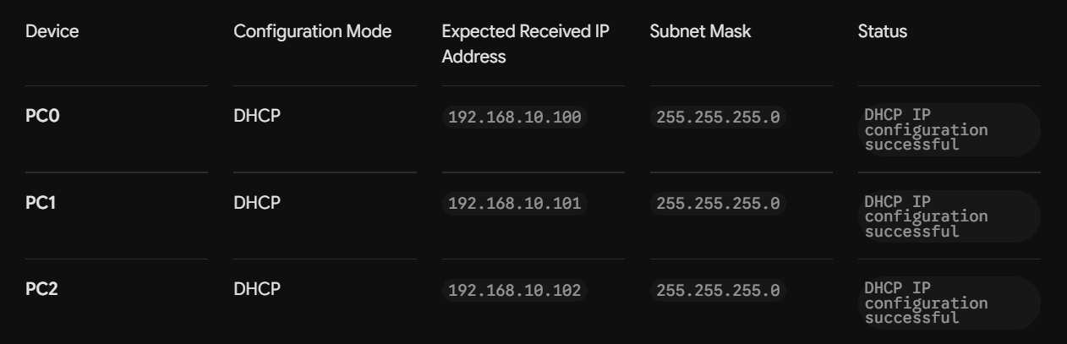

Step 5: Verify Inter-Device Connectivity
Open the Command Prompt on PC0 and run pings to confirm active communication:
DOS
ping 192.168.10.101
ping 192.168.10.102
- Configure a DNS service (using your router’s DNS settings or a tool like dnsmasq) so that typing a custom hostname (e.g., musicplayer.local) in a browser on any connected device opens a specific local web page or device interface. You can map hostnames to local IPs using the DNS service or by editing the hosts file for a quick test.
Answer
Quick Setup: Custom Local Domain (musicplayer.local)
1. Add Domain Entry to /etc/hosts
On your local server (IP: 192.168.1.50), open /etc/hosts and add:
Plaintext
192.168.1.50 musicplayer.local
2. Configure & Start dnsmasq
Install and restart dnsmasq so it serves the /etc/hosts entry to the local network:
Bash
sudo apt install dnsmasq -y
sudo systemctl restart dnsmasq
3. Update Client DNS & Test
- Set the Primary DNS on your router or client device to 192.168.1.50.
- Test resolution:
Bash
nslookup musicplayer.local

4.Create two VLANs (e.g., VLAN 10: 'Workstations', VLAN 20: 'Smart Devices') on your switch or simulation tool, assign at least two devices to each VLAN, and demonstrate that devices in the same VLAN can communicate, but not with devices in the other VLAN. Use ping or file sharing to test connectivity between devices in different VLANs.
Answer
VLAN Configuration and Connectivity Test
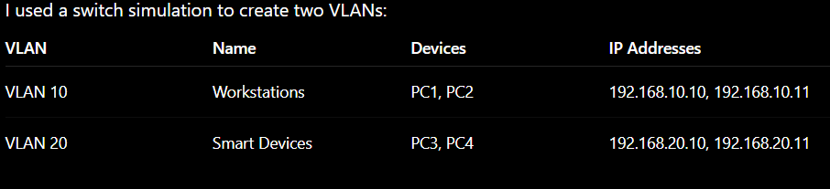
Cisco Switch Commands
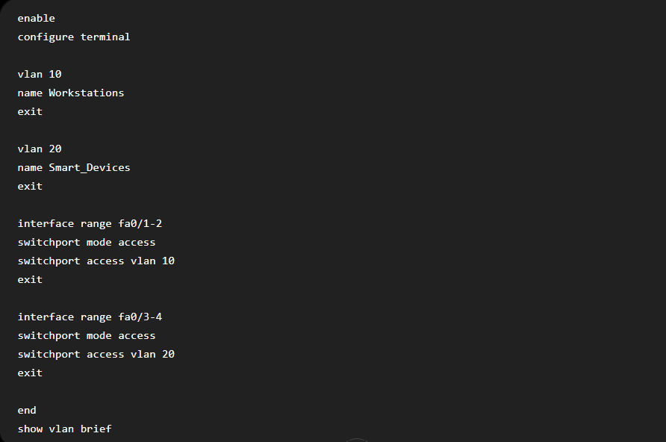
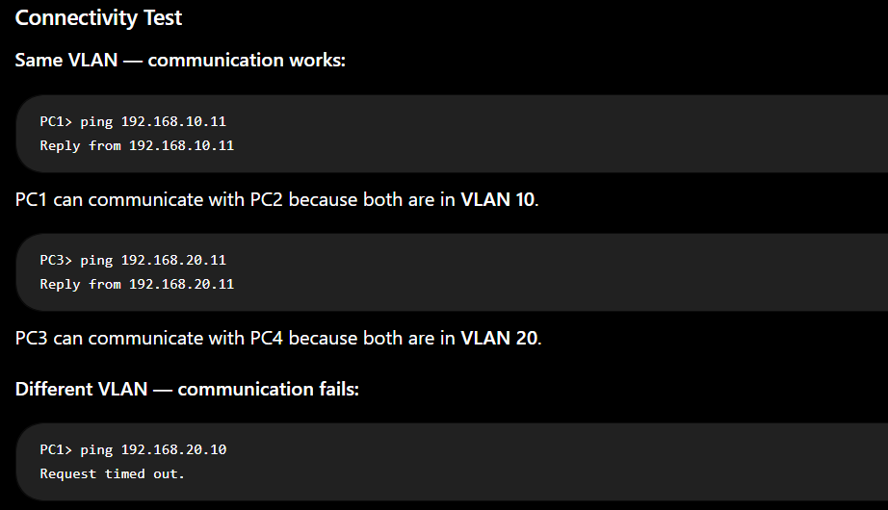
PC1 cannot communicate with PC3 because they belong to different VLANs and no inter-VLAN routing has been configured.
- Simulate internet access for your LAN by configuring a router with NAT (Network Address Translation), then test that devices on your LAN can access an external site (e.g., www.wikipedia.org) or a simulated external server.
Answer
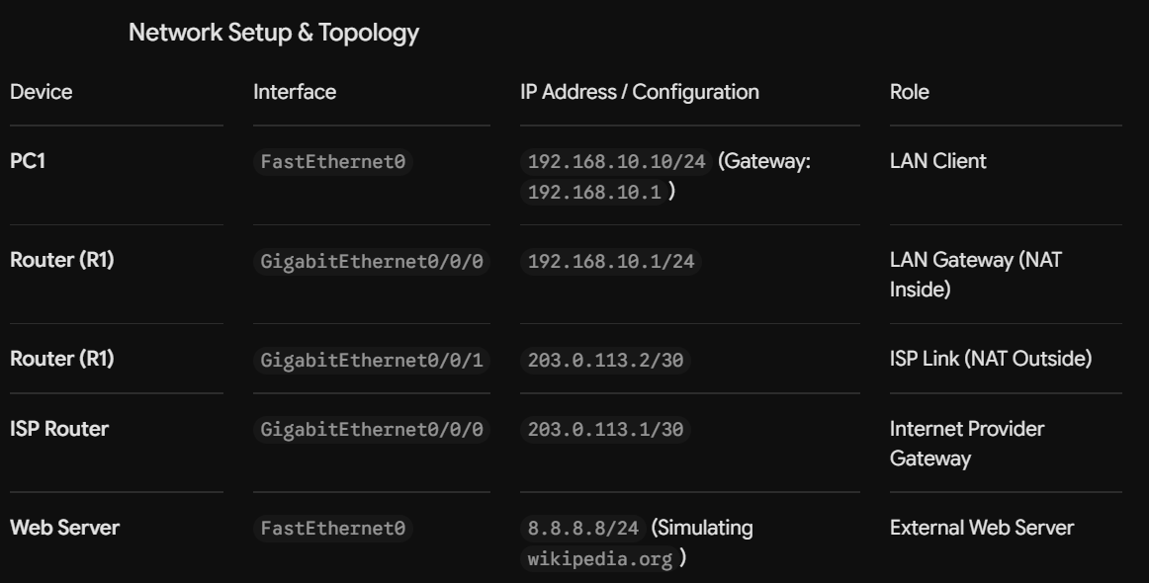

1. Assign IP Addresses
- PC1: 192.168.10.10/24 | Gateway: 192.168.10.1
- Server: 8.8.8.8/24 | Gateway: 8.8.8.1
